Q1- Launch Firefox browser & navigate to https://www.seleniumeasy.com/
a)Try to Fetch the alert popup text.
package selenium2;
import org.openqa.selenium.By;
import org.openqa.selenium.WebDriver;
import org.openqa.selenium.firefox.FirefoxDriver;

public class Question1 {
public static void main(String[] args){ System.setProperty("webdriver.gecko.driver","/home/nisha/Desktop/seleniumFiles/geckodriver-v0.26.0-linux64/geckodriver");
WebDriver driver =new FirefoxDriver();

driver.navigate().to("https://www.seleniumeasy.com/test/javascript-alert-box-demo.html");
driver.findElement(By.xpath("//button[@class='btn btn-default']")).click();
System.out.println(driver.switchTo().alert().getText());
}
}
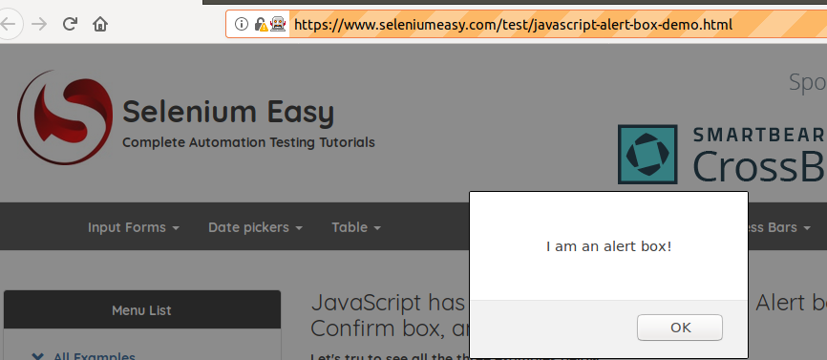
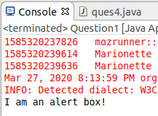

b)Try to Dismiss the popup.
package selenium2;
import org.openqa.selenium.By;
import org.openqa.selenium.WebDriver;
import org.openqa.selenium.firefox.FirefoxDriver;

public class Question2 {
public static void main(String[] args) { System.setProperty("webdriver.gecko.driver","/home/nisha/Desktop/seleniumFiles/geckodriver-v0.26.0-linux64/geckodriver");
WebDriver driver =new FirefoxDriver();

driver.navigate().to("https://www.seleniumeasy.com/test/javascript-alert-box-demo.html");
driver.findElement(By.cssSelector("button[onclick='myConfirmFunction()']")).click();
driver.switchTo().alert().dismiss();
System.out.println(driver.findElement(By.id("confirm-demo")).getText());
}
}
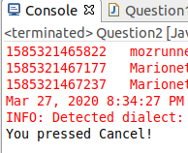
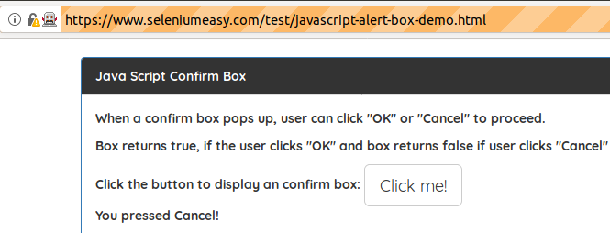

c)Try to enter some data on an alert popup.
package selenium2;
import org.openqa.selenium.By;
import org.openqa.selenium.WebDriver;
import org.openqa.selenium.firefox.FirefoxDriver;

public class Question1c {
public static void main(String[] args) { System.setProperty("webdriver.gecko.driver","/home/nisha/Desktop/seleniumFiles/geckodriver-v0.26.0-linux64/geckodriver");
WebDriver driver =new FirefoxDriver();

driver.navigate().to("https://www.seleniumeasy.com/test/javascript-alert-box-demo.html"); driver.findElement(By.cssSelector("button[onclick='myPromptFunction()']")).click();
driver.switchTo().alert().sendKeys("nisha");
}
}
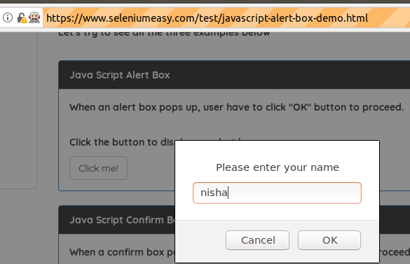

d)Try to accept the popup.
package selenium2;
import org.openqa.selenium.Alert;
import org.openqa.selenium.By;
import org.openqa.selenium.WebDriver;
import org.openqa.selenium.firefox.FirefoxDriver;

public class Question1c {
public static void main(String[] args) { System.setProperty("webdriver.gecko.driver","/home/nisha/Desktop/seleniumFiles/geckodriver-v0.26.0-linux64/geckodriver");
WebDriver driver =new FirefoxDriver();

driver.navigate().to("https://www.seleniumeasy.com/test/javascript-alert-box-demo.html");
driver.findElement(By.cssSelector("button[onclick='myPromptFunction()']")).click();
Alert prompt = driver.switchTo().alert();
prompt.sendKeys("nisha");
prompt.accept();
}
}
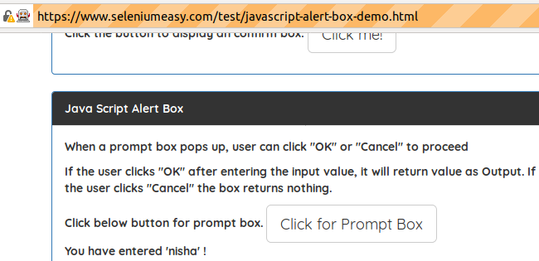

Q2-https://www.seleniumeasy.com/
Validate that Multi-Select List Demo is a multiple dropdown.
package selenium2;
import org.openqa.selenium.By;
import org.openqa.selenium.WebDriver;
import org.openqa.selenium.chrome.ChromeDriver;
import org.openqa.selenium.support.ui.Select;

public class Question2a {
public static void main(String[] args) {
System.setProperty("webdriver.chrome.driver", "/home/nisha/Desktop/seleniumFiles/chromedriver_linux64/chromedriver");
WebDriver driver = new ChromeDriver();

driver.navigate().to("https://www.seleniumeasy.com/test/basic-select-dropdown-demo.html");
Select dropdown = new Select(driver.findElement(By.id("multi-select")));
System.out.println(dropdown.isMultiple());
}
}

Fetch all the dropdown options
package selenium2;
import org.openqa.selenium.By;
import org.openqa.selenium.WebDriver;
import org.openqa.selenium.chrome.ChromeDriver;
import java.util.List;
import org.openqa.selenium.WebElement;

public class Quuestion2 {
public static void main(String[] args) {
System.setProperty("webdriver.chrome.driver", "/home/nisha/Desktop/seleniumFiles/chromedriver_linux64/chromedriver");
WebDriver driver = new ChromeDriver();

driver.navigate().to("https://www.seleniumeasy.com/test/basic-select-dropdown-demo.html");
List<WebElement> states = driver.findElements(By.xpath("//*[@id=\'multi-select\']"));
for(int i=0;i<states.size();i++) {
String options = driver.findElements(By.xpath("//*[@id=\'multi-select\']")).get(i).getText();
System.out.println("Options of drop down are: " +options);
} }
}
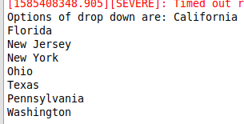

Select New Jersey>New York>Texas then fetch first selected option & all selected options.
package selenium2;
import java.util.concurrent.TimeUnit;
import org.openqa.selenium.By;
import org.openqa.selenium.Keys;
import org.openqa.selenium.WebDriver;
import org.openqa.selenium.WebElement;
import org.openqa.selenium.chrome.ChromeDriver;
import org.openqa.selenium.interactions.Actions;
import org.openqa.selenium.support.ui.Select;
public class Question2c {
public static void main(String[] args) throws InterruptedException {
System.setProperty("webdriver.chrome.driver", "/home/nisha/Desktop/seleniumFiles/chromedriver_linux64/chromedriver");
WebDriver driver = new ChromeDriver();
driver.navigate().to("https://www.seleniumeasy.com/test/basic-select-dropdown-demo.html");
driver.manage().timeouts().implicitlyWait(10, TimeUnit.SECONDS);
WebElement select1 = driver.findElement(By.xpath("//option[contains(text(),'New Jersey')]"));
WebElement select2 = driver.findElement(By.xpath("//option[contains(text(),'New York')]"));
WebElement select3 = driver.findElement(By.xpath("//option[contains(text(),'Texas')]"));

Actions actions = new Actions(driver);
Thread.sleep(2000);
actions.keyDown(Keys.CONTROL)
.moveToElement(select1).click()
.moveToElement(select2).click()
.moveToElement(select3).click()
.build()
.perform();

Thread.sleep(5000);
driver.findElement(By.id("printAll")).click();
System.out.println(driver.findElement(By.xpath("//p[@class='getall-selected']")).getText());
Thread.sleep(2000);
driver.findElement(By.id("printMe")).click();
System.out.println(driver.findElement(By.xpath("//p[@class='getall-selected']")).getText());

Select items = new Select(driver.findElement(By.xpath("//select[@id='multi-select']")));
items.deselectAll();
}}
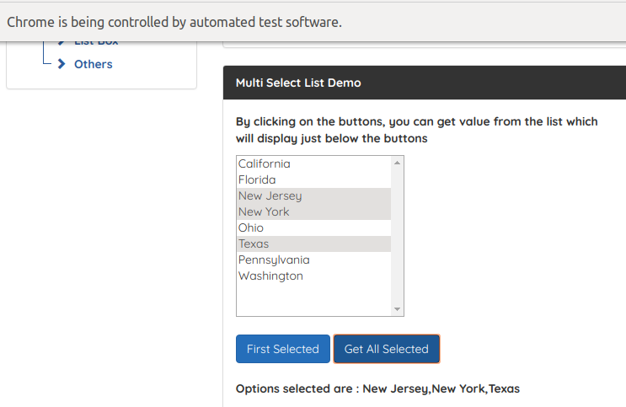

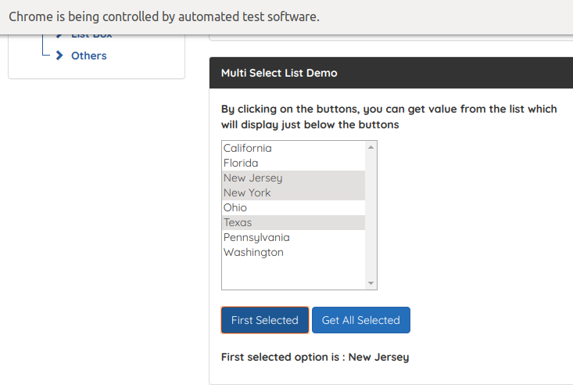

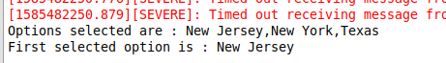

Deselect all the selected options.
Select items = new Select(driver.findElement(By.xpath("//select[@id='multi-select']")));
items.deselectAll();

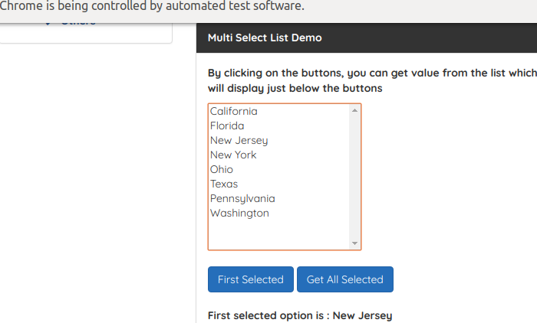

Q3- Difference between implicit & explicit wait along with syntax.
Implicit Wait:
Implicit Wait directs the Selenium WebDriver to wait for a given time before throwing an exception of "No Such Element Exception".

Syntax:
driver.manage().timeouts().implicitlyWait(10,TimeUnit.SECONDS) ;

Implicit wait will accept 2 parameters, the first parameter will accept the time as an integer value and the second parameter will accept the time measurement (sec,min,hours,ms etc).
- Implicit wait is applied to all the elements in the script.
- In implicit wait, no need to specify “ExpectedConditions” on the element to be located.

Explicit Wait:
The explicit wait is used to tell the Web Driver to wait for certain conditions (Expected Conditions) or the maximum time exceeded before throwing an "ElementNotVisibleException" exception.
It is the custom one. It will be used if we want the execution to wait for some time until some condition achieved.It can be implemented by the WebDriverWait class.

Syntax:
WebDriverWait wait = new WebDriverWait(WebDriverRefrence,TimeOut);

- Explicit wait time is applied only to those elements that are specified by us.
- In explicit wait, we need to specify the “ExpectedConditions” on the element to be located

Q4-http://demo.automationtesting.
Enter the value in the filed under single Iframe as well as Iframe within an Iframe in a single script.
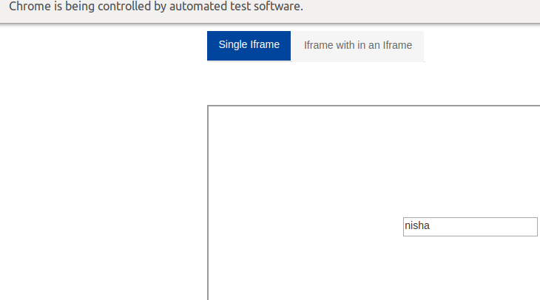

package selenium2;

import org.openqa.selenium.By;
import org.openqa.selenium.WebDriver;
import org.openqa.selenium.WebElement;
import org.openqa.selenium.chrome.ChromeDriver;

public class Question4 {

public static void main(String[] args) throws InterruptedException {
System.setProperty("webdriver.chrome.driver", "/home/nisha/Desktop/seleniumFiles/chromedriver_linux64/chromedriver");
WebDriver driver = new ChromeDriver();
driver.navigate().to("http://demo.automationtesting.in/Frames.html");
driver.switchTo().frame(0);
Thread.sleep(2000);
WebElement text=driver.findElement(By.xpath("//input[@type='text']"));
text.sendKeys("nisha");
driver.switchTo().defaultContent();

}

}

Iframe within Iframe
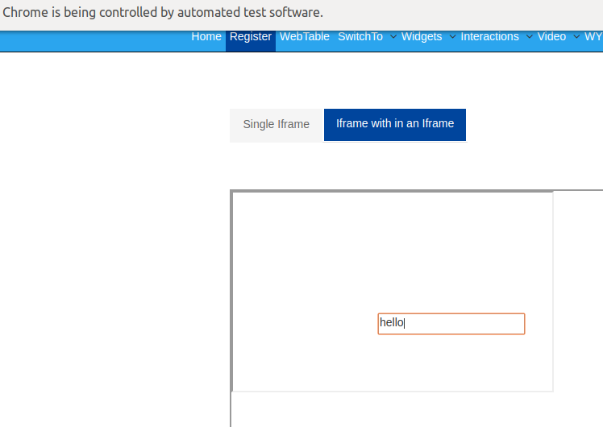
package selenium2;
import org.openqa.selenium.By;
import org.openqa.selenium.WebDriver;
import org.openqa.selenium.WebElement;
import org.openqa.selenium.chrome.ChromeDriver;

public class Question4 {

public static void main(String[] args) throws InterruptedException {
System.setProperty("webdriver.chrome.driver", "/home/nisha/Desktop/seleniumFiles/chromedriver_linux64/chromedriver");
WebDriver driver = new ChromeDriver();
driver.navigate().to("http://demo.automationtesting.in/Frames.html");
driver.switchTo().frame(0);
Thread.sleep(2000);
WebElement text=driver.findElement(By.xpath("//input[@type='text']"));
text.sendKeys("nisha");
driver.switchTo().defaultContent();
driver.findElement(By.xpath("//a[@href='#Multiple']")).click(); driver.switchTo().frame(driver.findElement(By.cssSelector("iframe[src='MultipleFrames.html']")));
Thread.sleep(2000);
driver.switchTo().frame(driver.findElement(By.cssSelector("iframe[src='SingleFrame.html']")));
Thread.sleep(2000);
driver.findElement(By.cssSelector("input[type='text']")).sendKeys("hello");

}

}
Q5-http://demo.automationtesting.
Print the count of frames on this application.

package selenium2;

import org.openqa.selenium.By;
import org.openqa.selenium.WebDriver;
import org.openqa.selenium.chrome.ChromeDriver;

public class Question5 {

public static void main(String[] args) {
System.setProperty("webdriver.chrome.driver", "/home/nisha/Desktop/seleniumFiles/chromedriver_linux64/chromedriver");
WebDriver driver = new ChromeDriver();
driver.navigate().to("http://demo.automationtesting.in/Frames.html");
System.out.println("Total number of iframes: "+driver.findElements(By.tagName("iframe")).size());
}

}

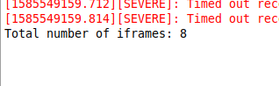

Q6-https://www.toolsqa.com/
Click on New Browser Tab then click on Blog Tab in the newly opened window.
package selenium2;
import java.awt.AWTException;
import java.awt.Robot;
import java.awt.event.KeyEvent;
import org.openqa.selenium.By;
import org.openqa.selenium.WebDriver;
import org.openqa.selenium.chrome.ChromeDriver;
import java.util.*;

public class Question6 {
public static void main(String[] args) throws AWTException {
System.setProperty("webdriver.chrome.driver", "/home/nisha/Desktop/seleniumFiles/chromedriver_linux64/chromedriver");
WebDriver driver = new ChromeDriver();
driver.navigate().to("https://www.toolsqa.com/automation-practice-switch-windows/");

Robot robo = new Robot();
robo.keyPress(KeyEvent.VK_CONTROL);
robo.keyPress(KeyEvent.VK_T);
robo.keyRelease(KeyEvent .VK_CONTROL);
robo.keyRelease(KeyEvent .VK_T);
ArrayList<String> ids = new ArrayList<String>(driver.getWindowHandles());
driver.switchTo().window(ids.get(1));
driver.navigate().to("https://www.toolsqa.com/automation-practice-switch-windows/");
driver.findElement(By.xpath("//nav[@class='navigation']//span[@class='menu-text'][contains(text(),'Blogs')]")).click();
}
}

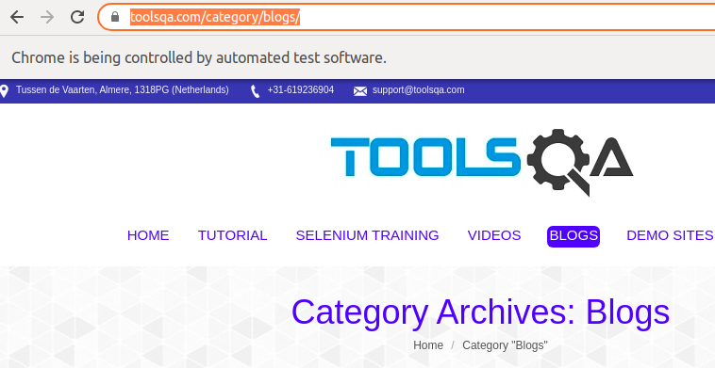
Q7-https://www.myntra.com/
Mouse hover on the Home & Living tab then click clock, now validate that navigated URL is for clock section.

package selenium2;
import org.openqa.selenium.By;
import org.openqa.selenium.WebDriver;
import org.openqa.selenium.WebElement;
import org.openqa.selenium.chrome.ChromeDriver;
import org.openqa.selenium.interactions.Actions;

public class Question7 {
public static void main(String[] args) {
System.setProperty("webdriver.chrome.driver","/home/nisha/Desktop/seleniumFiles/chromedriver_linux64/chromedriver");
WebDriver driver= new ChromeDriver();
driver.navigate().to("https://www.myntra.com/");
WebElement homeliving = driver.findElement(By.xpath("(//a[@href='/shop/home-living'])[1]"));
Actions element= new Actions(driver);
element.moveToElement(homeliving).perform();
WebElement clock=driver.findElement(By.xpath("//a[@href='/clocks']"));
clock.click();
String URL=driver.getCurrentUrl();
System.out.println(URL.equals("https://www.myntra.com/clocks"));
}
}

